Chapter 2, Problem 51.

Obtain the equivalent resistance at the terminals a-b for each of the circuits in Fig. 2.115.
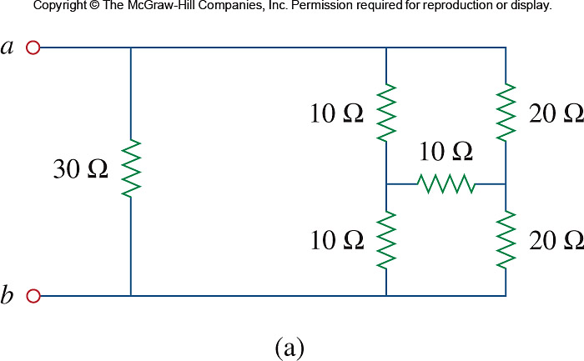

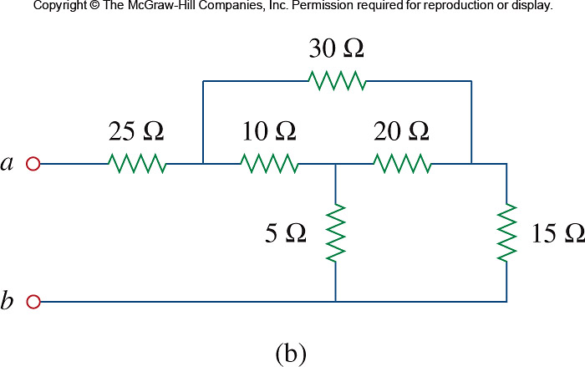

Figure 2.115
For Prob. 2.51.

